Adding Honors Restrictions
- Log into banner and pull up SSASECT
- Type in desired CRN and hit next block
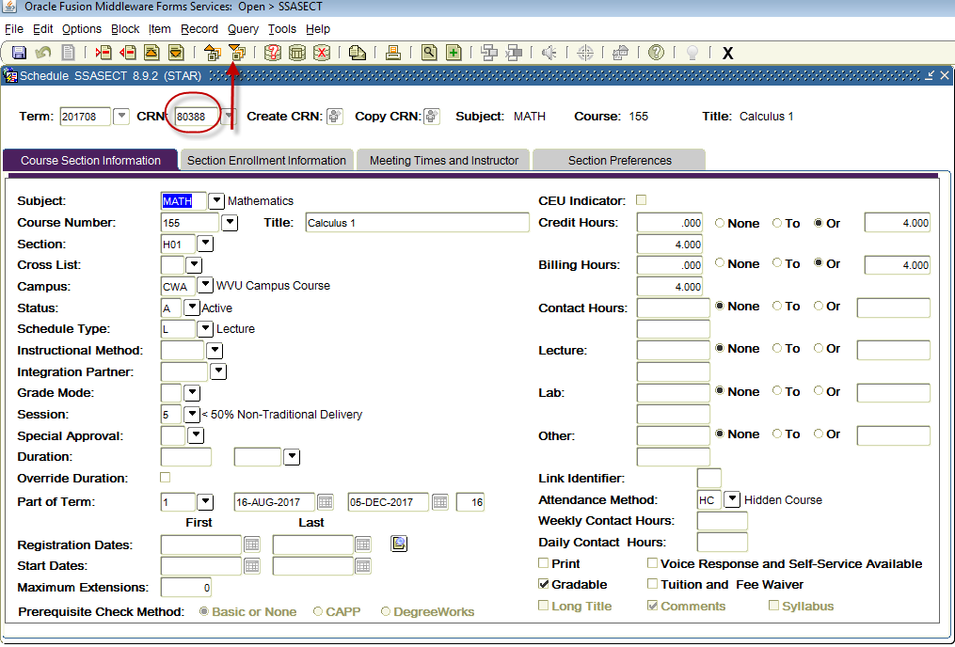
- As of 201708 make sure DA is not on the honors course.
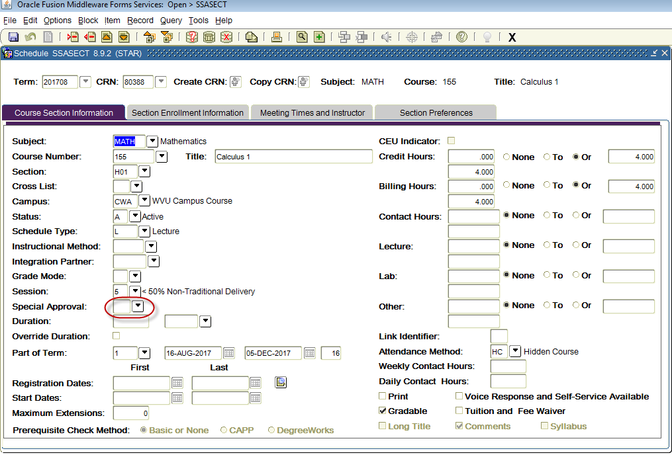

- Then click on options in the top left portion of the screen and select SSARRES
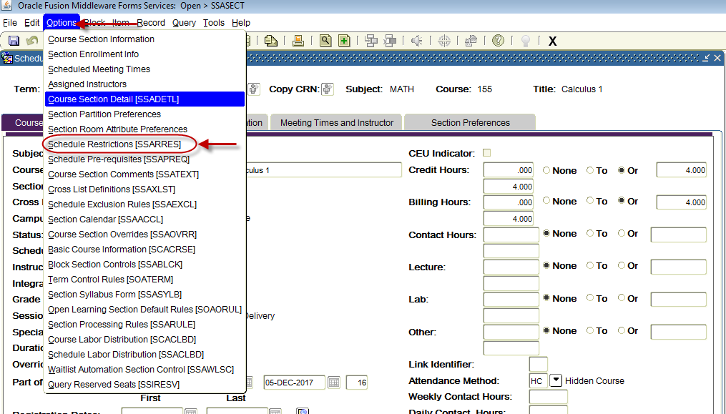5. Once you are on the SSARRES make sure the desired CRN is filled in, click next block, and then click Student Attribute and Cohort.
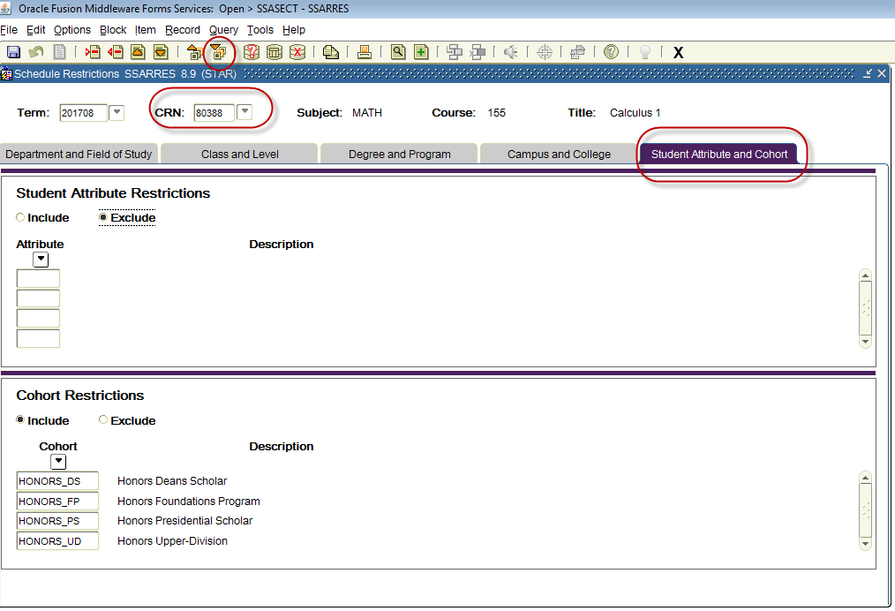

- Lastly make sure to enter the following Restrictions and that Include is selected.
  - HONORS_DS
  - HONORS_FP
  - HONORS_PS
  - HONORS_UD
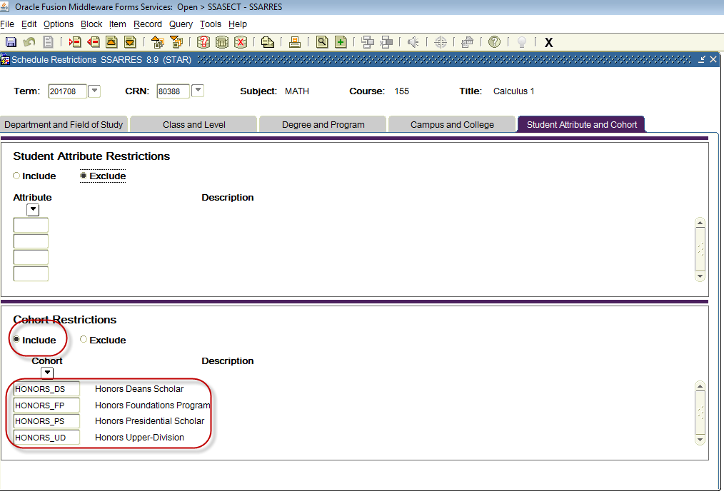
- Make sure to click save and then proceed to next CRN.

