How to Request an Event for HSC SLI Coordinators
This instruction is used to complete an event request in 25Live for a semester long event that is NOT a CRN in Banner but still needs a room assigned during the S25 run.
- To access 25Live: https://25live.collegenet.com/wvu
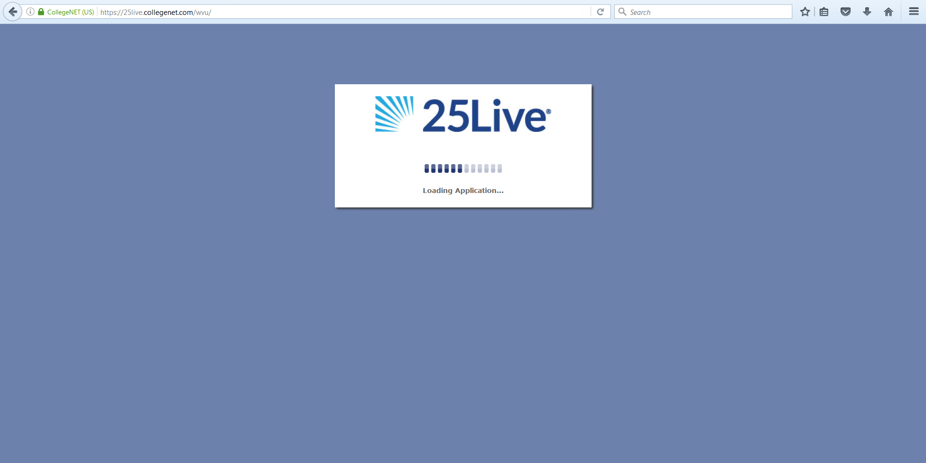

- Click “Sign In” to begin the process of requesting space through 25Live. You will need to sign in with your My ID username and password.

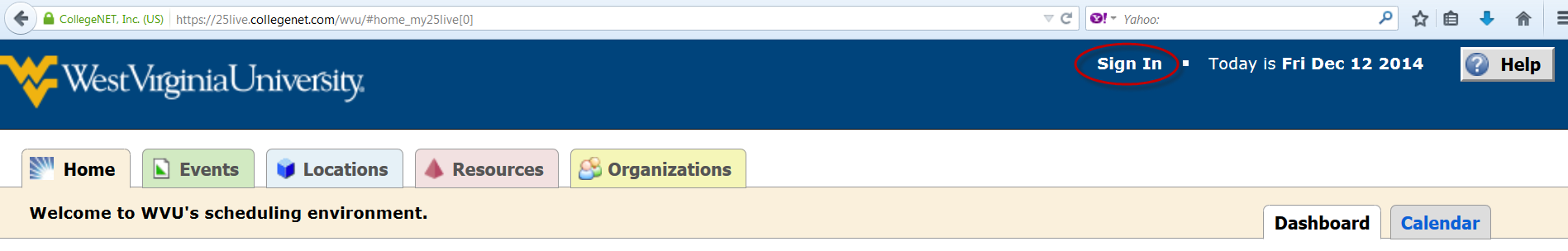

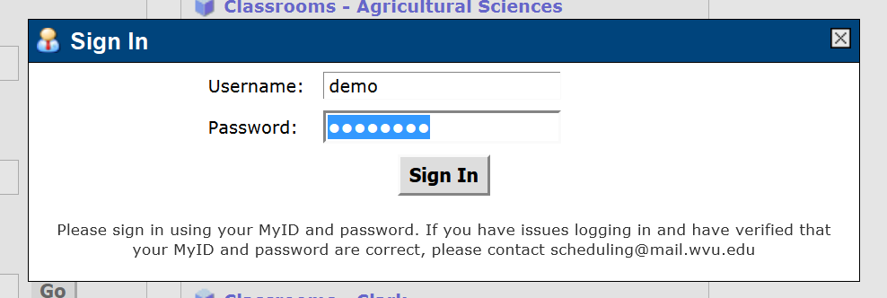

- Select “Even Wizard” tab or click on “Create an Event” button to start your event request.

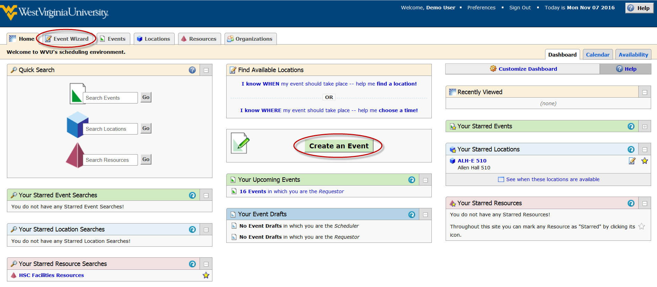

- The “Event Wizard” tab will load.
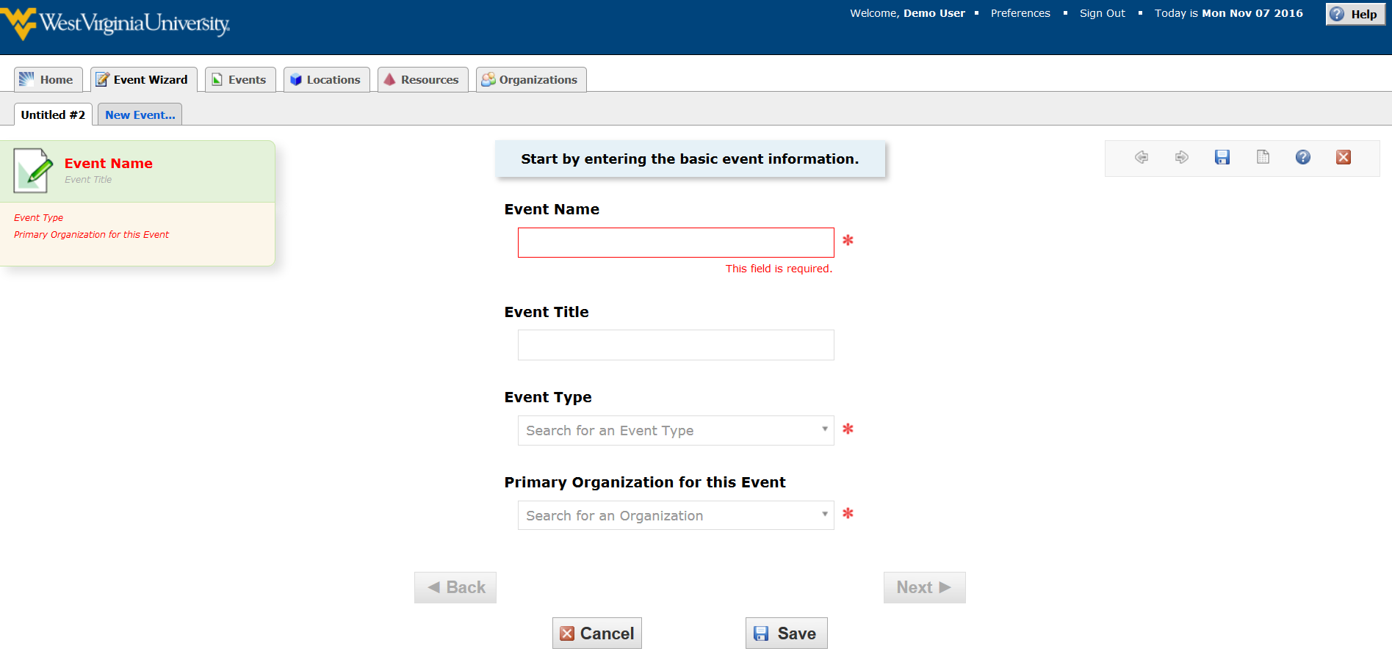

- Enter an Event Name (required) and put a more descriptive Event Title if desired. The Event Name and Event Title will display on published calendars. Avoid acronyms and name the event in a way that will be understandable to others.

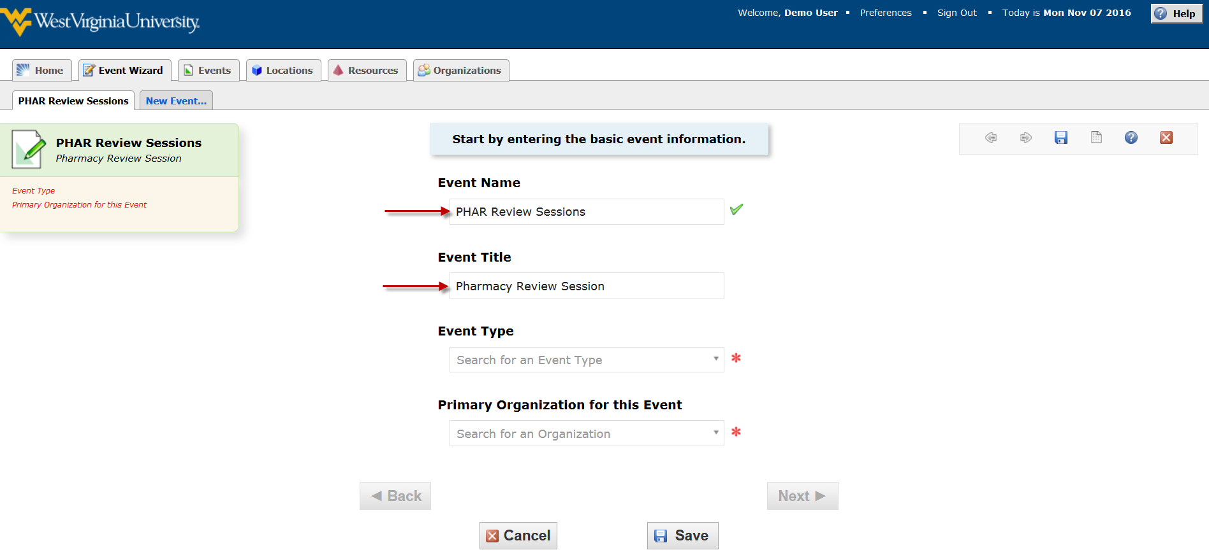

- Select an “HSC – S25 Assignable Events” Event Type (required).
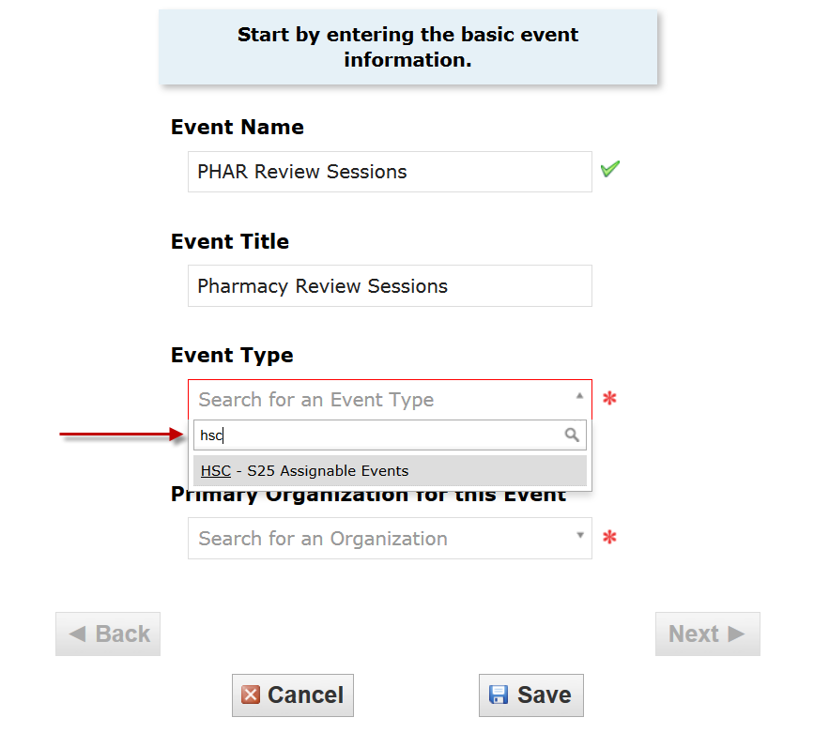

- Select a Primary Organization (required) that will sponsor the event. Always pick organization that is the subject code from Banner and “HSC S25 EVENTS” description (e.g. PHAR– HSC S25 EVENTS). You can type an organization name or Browse to search the organization name by index or type.

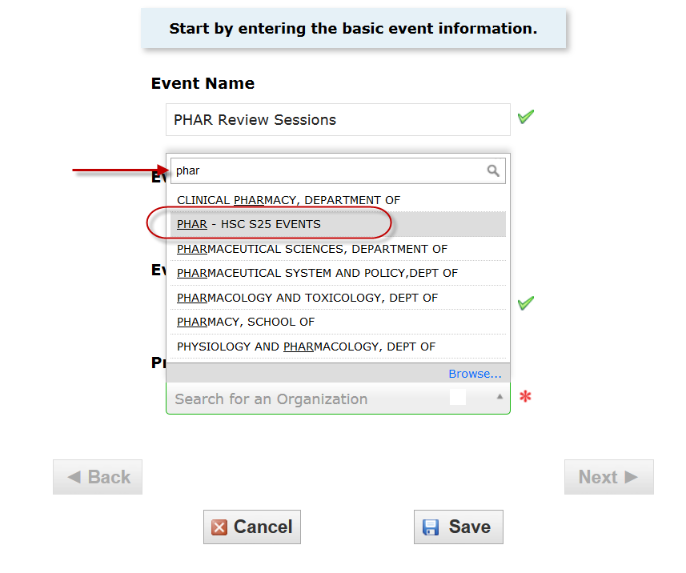
This is what you see if you click on Browse. Do not use the categories option.
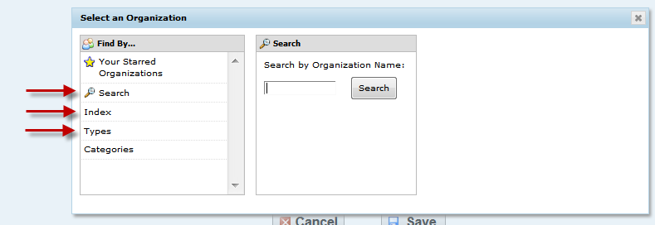

- Hit the “Next” button to go on to the second page of the request form.
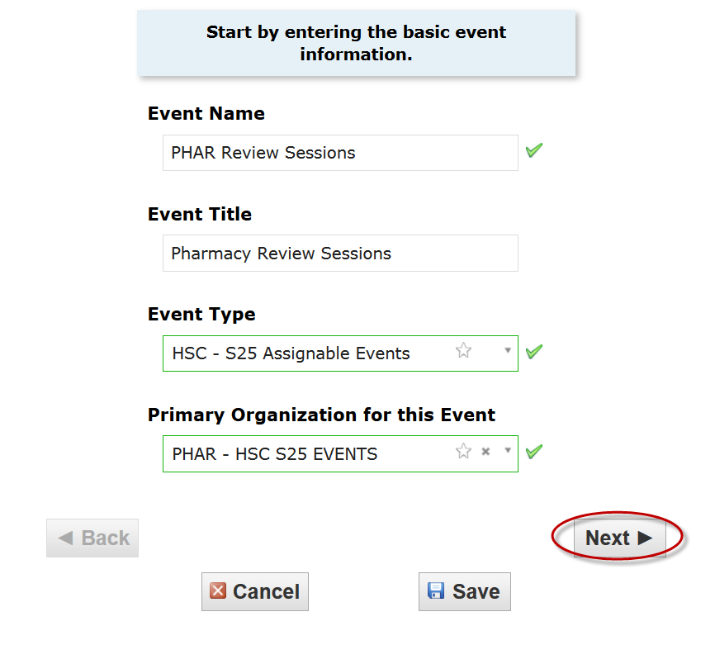
- Enter an Expected Head Count (required) and hit “Next” Button.

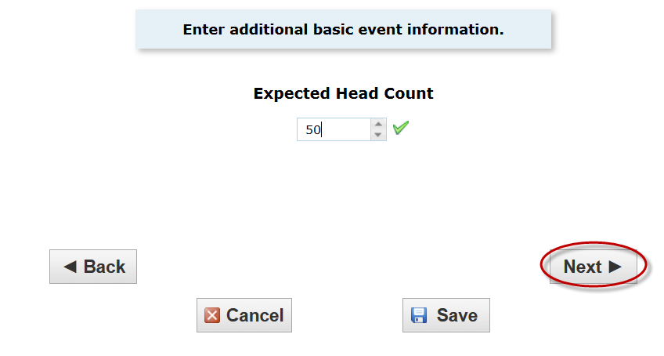

- Select “Yes” as you need a room assigned for the whole semester.
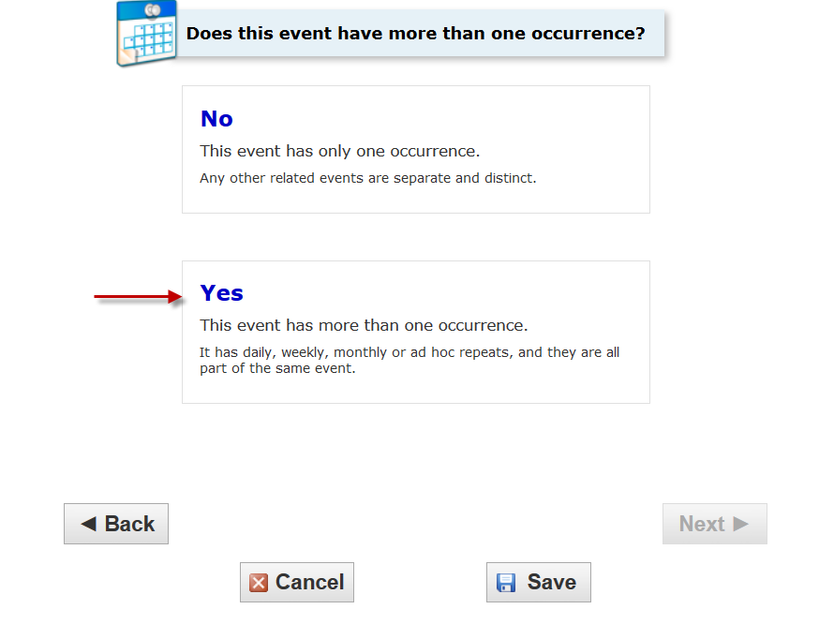
- Enter the Event Date and Time (required). Pick the first day of the semester for the event start date. You can manually type in the times that you need if your event needs to end 10 minutes before the hour or any other time than what is listed in the drop down. You Should NOT need enter pre-event/setup or post-event/takedown additional time if necessary. This may impact the availability of a room requested. Stick with the start and end time of your event only. Then hit “Next” Button to go to the location page.
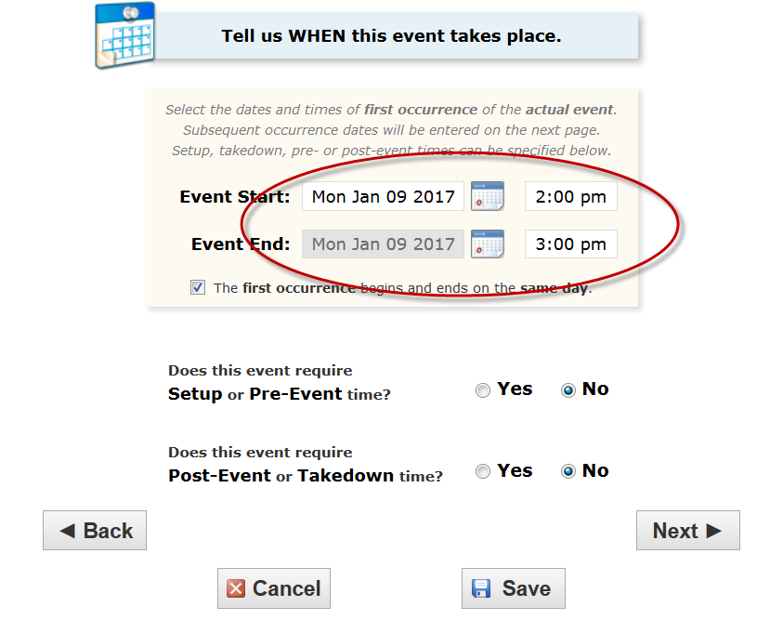
- Select “Weekly Repeats” and go to the next page. 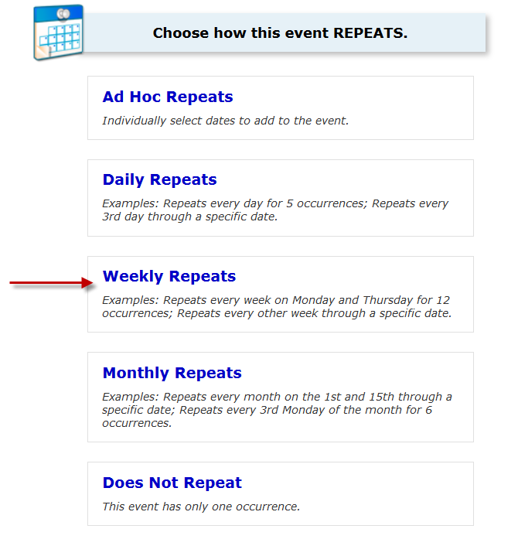

- This allows you to create a meeting pattern every week that repeats until the end of the semester. Please do not use the “Ends after X iterations” option.
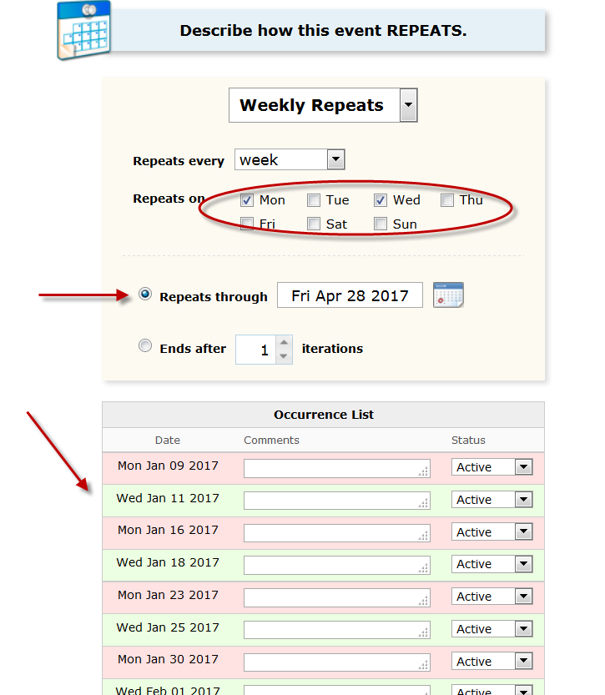
- Hit Next to go to the next page.
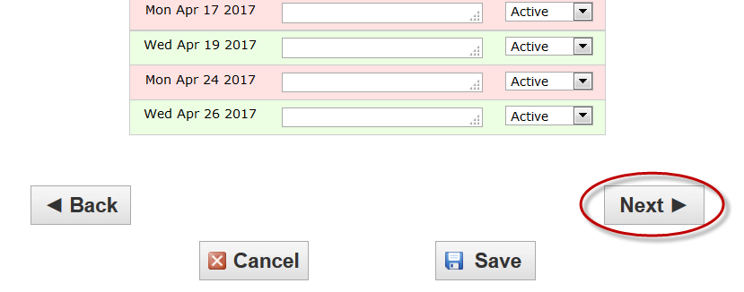
- Type “Needs Space” in the box of “Search by Location Name” and select it.
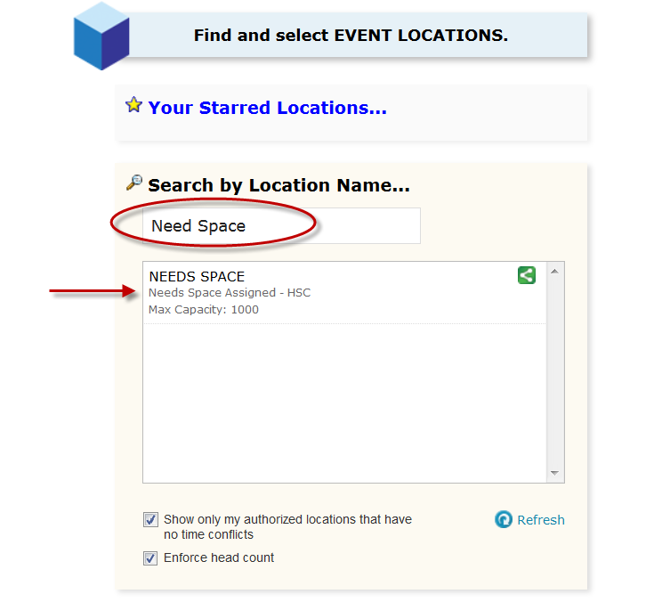
- Make sure it is assigned with a green check mark. Hit Next.
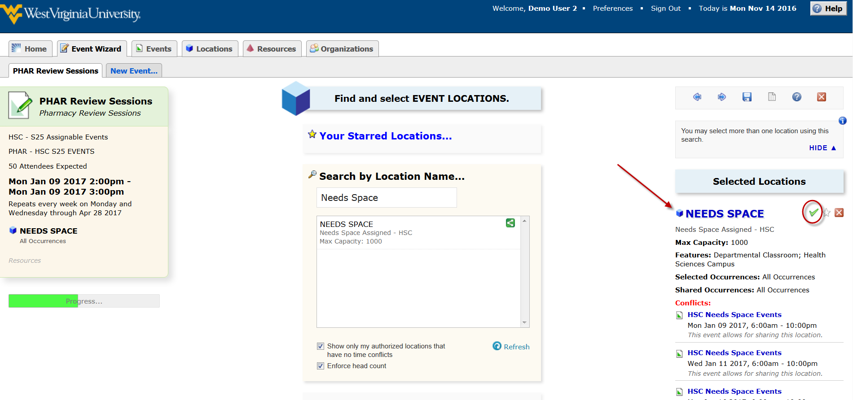
- Leave the resources blank and hit Next to go to the next page. 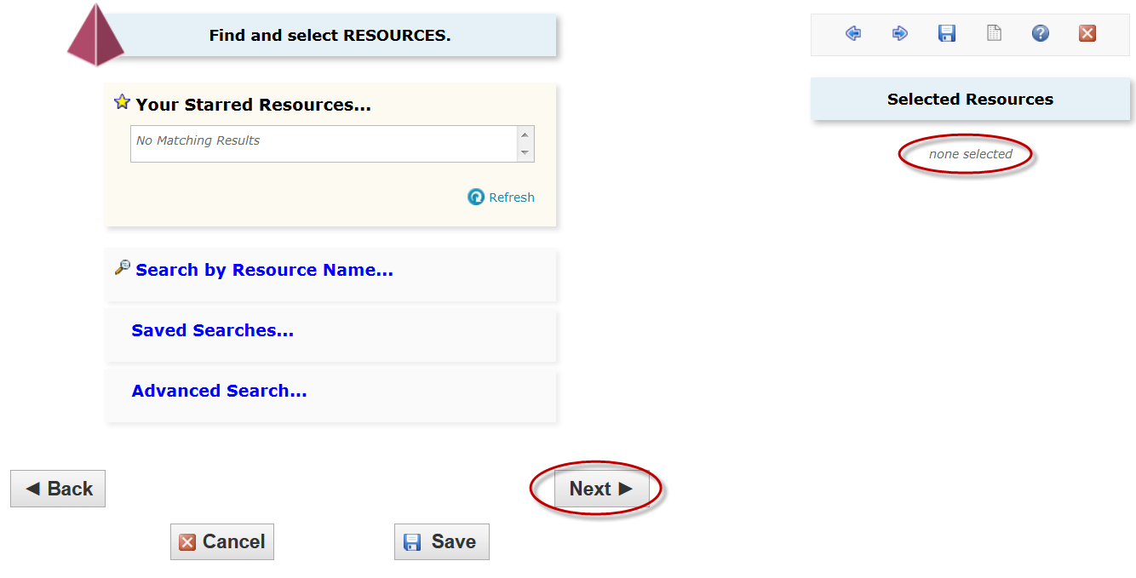
- If you have someone that you would like to list on the request in addition to yourself please fill out the following custom attributes. This is completely optional. If you don’t need someone else included just click the “Next” button. –
Contact Email Address
Contact Name
Contact Phone Number
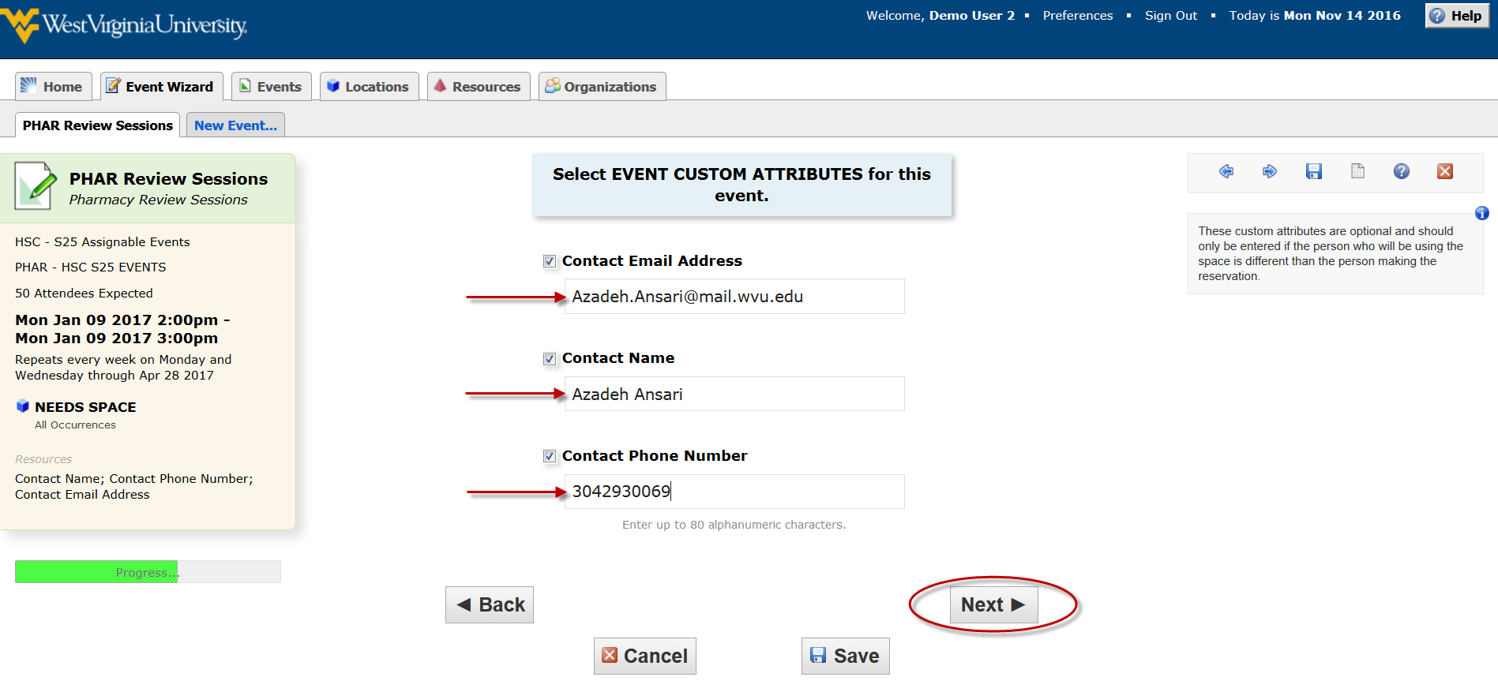

- You should pick the categories (Room Features) you need form the list. Make sure you select “General Purpose Classroom” and “Health Sciences Campus”. Also, select the technology you need (e.g. HSC Premium Room).
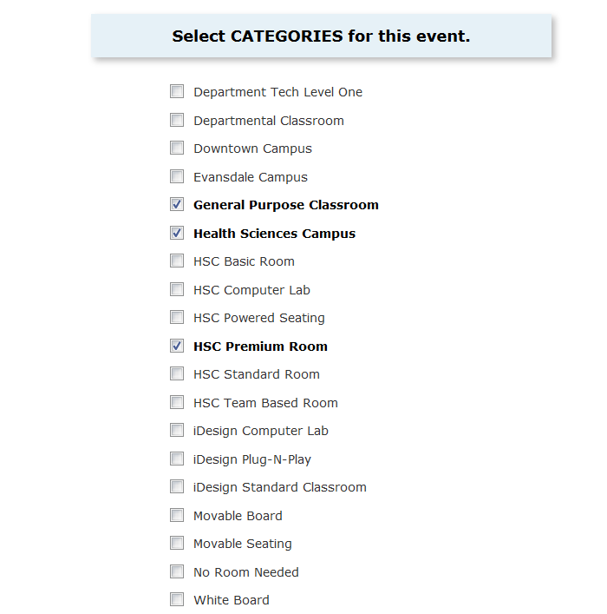
- Enter any Event Comments if necessary. Information entered here will be viewed by the space manager only when looking over the request. Then Click on “Next” button.
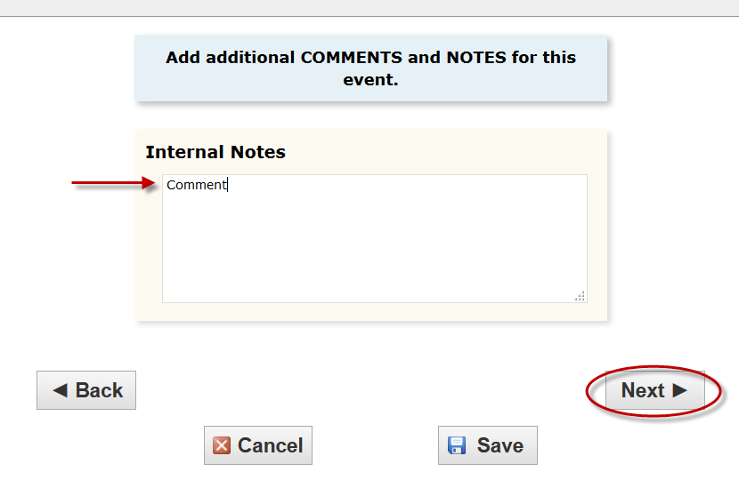
- Review the Terms of Use Policy and click “I Agree” to continue with your assignment. Hit “Next” to go to the final page of room request.
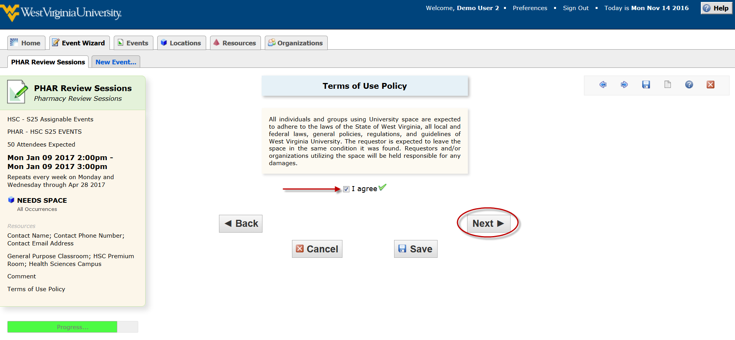
- If you need to switch the date/time of the request to find the space you want, select the “Back”. This will bring you back to the page of the event request and you can adjust the date/time there.
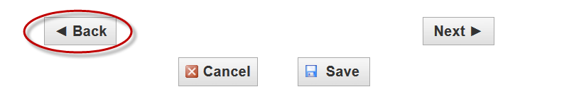

- Then hit “Next” Button to go to the contact information page and hit “Next” Button.
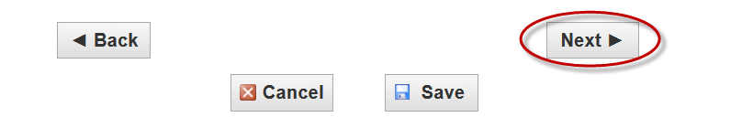
- Select “Confirmed” as you Event State and hit “Save” button.

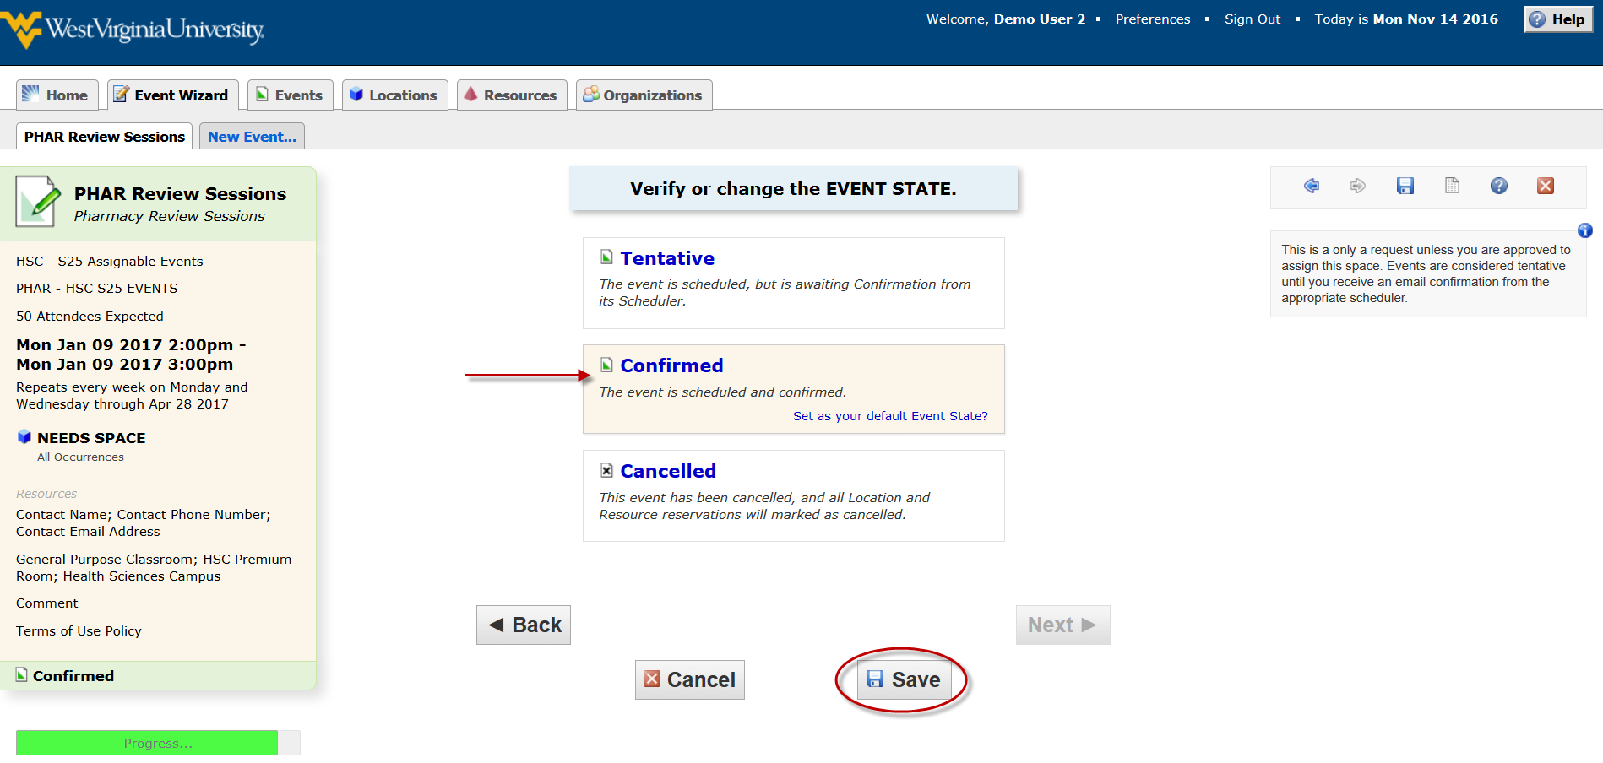

- If there are no errors in your event form or event request, you will receive a screen that lets you know that your event has been successfully saved. To view or edit your event, you will need “Reference Number” for this event which can be found on this page.
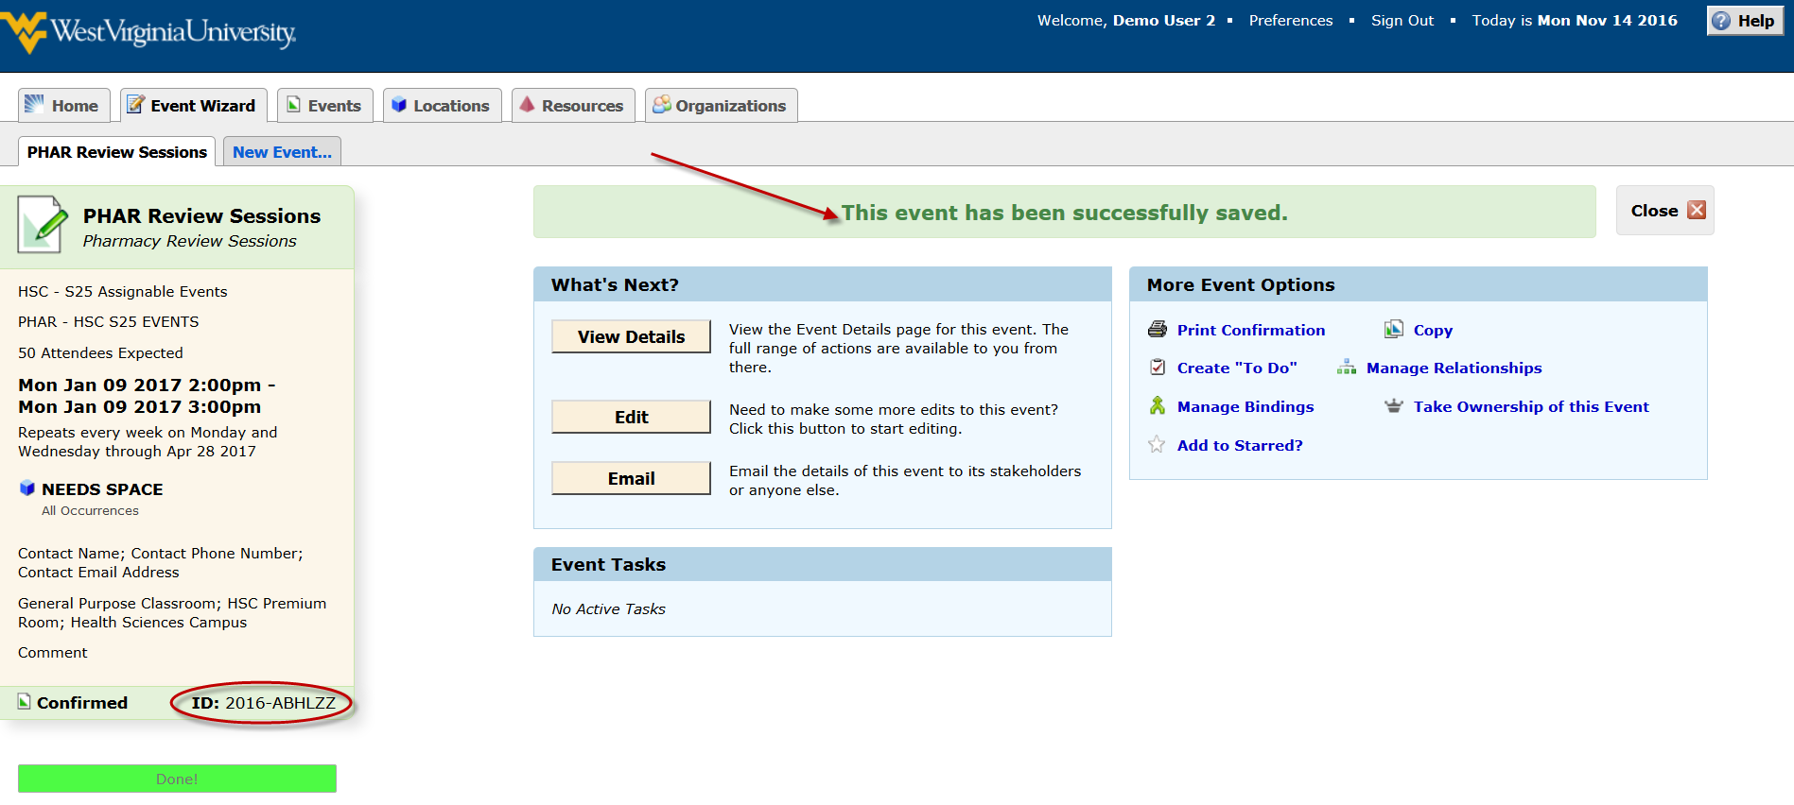
- You will also receive an email letting you know that you event has been requested.

Questions? Contact scheduling@mail.wvu.edu

